# Adding and Subtracting Polynomials

We can add and subtract polynomials by combining like terms and simplifying. Remember, “like” terms contain the same variables raised to the same exponents.

Examples: Simplify each expression by combining like terms.

$(2x^{3}+5x^{2}-x+1)+(2x^{2}-3x-4)$

$\left(-7x^{3}-7x^{2}+6x-2\right)-(4x^{3}-6x^{2}-x+7)$

# Multiplying Polynomials

One method of multiplying polynomials requires using the distributive property and then combining like terms.

Another method is to use the Area Model:

If we want to multiply $(x + 1)(3x – 2$), assign each binomial to a side of the rectangle.

Our goal is to calculate the area of the full rectangleby splitting the side lengths into more manageable parts.

Use “ $x + 1$” and subdivide the side of the rectangle.

Use “ $3x – 2$” and subdivide the top of the rectangle.

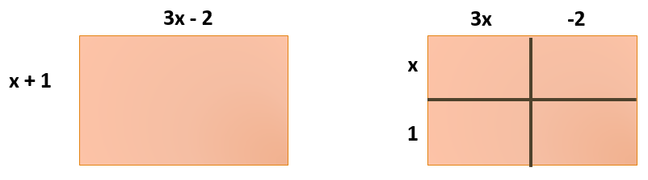

Then fill in the area of each internal rectangle.

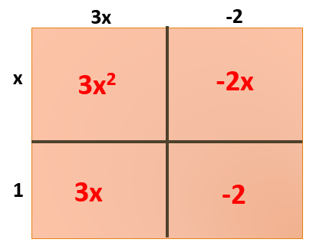

Finally add up all of the areas and combine like terms:

$3x^{2} – 2x + 3x - 2 =$ $3x^{2}+x-2$

Examples: Simplify each expression by multiplying and combining like terms. Use the area model or the distributive property.

$(2x+1)(3x^{2}-x+4)$

$(5x-18)(3x+1)$

${(4x-1)}^{2}$

$(2x+3)(2x-3)$

$(x+4)(3x-2y+5)$